As filed with the U.S. Securities and Exchange Commission on May 14, 2026.

Registration No. 333-

UNITED STATES

SECURITIES AND EXCHANGE COMMISSION

Washington, D.C. 20549

FORM S-8

REGISTRATION STATEMENT

UNDER

THE SECURITIES ACT OF 1933

Cerebras Systems Inc.

(Exact name of Registrant as specified in its charter)

Delaware

81-2256092

(State or other jurisdiction of
Incorporation or organization)

(I.R.S. Employer
Identification No.)

1237 E. Arques Avenue

Sunnyvale, California 94085

(650) 933-4980

(Address of Principal Executive Offices) (Zip Code)

Cerebras Systems Inc. 2016 Equity Incentive Plan

Cerebras Systems Inc. 2026 Incentive Award Plan

Cerebras Systems Inc. 2026 Employee Stock Purchase Plan
(Full title of the plan)

Andrew D. Feldman

Chief Executive Officer and President

Cerebras Systems Inc.

1237 E. Arques Avenue

Sunnyvale, California 94085

(650) 933-4980
(Name, address and telephone number, including area code, of agent for service)

 | Copies to:
Tad J. Freese | Shirley X. Li
Sarah B. Axtell | Shirley X. Li
Sarah B. Axtell | Christopher Ing
Zuzanna V. Gruca | Christopher Ing
Zuzanna V. Gruca | Cerebras Systems Inc.
Latham & Watkins LLP | Cerebras Systems Inc.
Latham & Watkins LLP | 1237 E. Arques Avenue
801 Jefferson Avenue, Suite 300 | 1237 E. Arques Avenue
801 Jefferson Avenue, Suite 300 | Sunnyvale, California 94085
Redwood City, California 94063 | Sunnyvale, California 94085
Redwood City, California 94063 | (650) 933-4980
(650) 328-4600 | (650) 933-4980

Indicate by check mark whether the registrant is a large accelerated filer, an accelerated filer, a non-accelerated filer, a smaller reporting company, or an emerging growth company. See the definitions of “large accelerated filer,” “accelerated filer,” “smaller reporting company,” and “emerging growth company” in Rule 12b-2 of the Exchange Act.

Large accelerated filer | o | Accelerated filer | o
Non-accelerated filer | x | Smaller reporting company | o
 |  | Emerging growth company | x

If an emerging growth company, indicate by check mark if the registrant has elected not to use the extended transition period for complying with any new or revised financial accounting standards provided pursuant to Section 7(a)(2)(B) of the Securities Act. o

PART I

INFORMATION REQUIRED IN THE SECTION 10(a) PROSPECTUS

The information called for in Part I of Form S-8 to be contained in the Section 10(a) prospectus is not being filed with or included in this Registration Statement (by incorporation by reference or otherwise) in accordance with the rules and regulations of the Securities and Exchange Commission (the “SEC”). The documents containing the information specified in Part I of Form S-8 will be delivered to the participants in the equity benefit plans covered by this Registration Statement as specified by Rule 428(b)(1) under the Securities Act of 1933, as amended (the “Securities Act”).

PART II

INFORMATION REQUIRED IN REGISTRATION STATEMENT

Item 3. Incorporation of Documents by Reference.

The following documents filed by Cerebras Systems Inc. (the “Registrant”) with the SEC are incorporated by reference into this Registration Statement:

- Amendment No. 2 to the Registrant’s Registration Statement on Form S-1 filed with the SEC on May 11, 2026 (File No. 333-295145), which contains the Registrant’s audited financial statements for the latest fiscal year for which such statements have been filed;

- the Registrant’s Prospectus to be filed on or about May 14, 2026 pursuant to Rule 424(b) under the Securities Act, relating to the Registration Statement on Form S-1, as amended (File No. 333-295145); and

- the description of the Registrant’s Class A common stock contained in the Registrant’s Registration Statement on Form 8-A (File No. 001-43284), filed by the Registrant with the SEC under Section 12(b) of the Exchange Act on May 11, 2026, including any amendment or report filed for the purpose of updating such description.

All reports and documents filed by the Registrant pursuant to Sections 13(a), 13(c), 14, and 15(d) of the Securities Exchange Act of 1934, as amended (the “Exchange Act”) (other than Current Reports furnished under Item 2.02 or Item 7.01 of Form 8-K and exhibits furnished on such form that relate to such items) on or after the date of this Registration Statement and prior to the filing of a post-effective amendment to this Registration Statement that indicates that all securities offered have been sold or that deregisters all securities then remaining unsold shall be deemed to be incorporated by reference in this Registration Statement and to be part hereof from the date of filing of such reports and documents. Any statement contained in a document incorporated or deemed to be incorporated by reference herein shall be deemed to be modified or superseded for purposes of this Registration Statement to the extent that a statement contained herein or in any subsequently filed document which also is deemed to be incorporated by reference herein modifies or supersedes such statement. Any such statement so modified or superseded shall not be deemed, except as so modified or superseded, to constitute a part of this Registration Statement.

Item 4. Description of Securities.

See the description of the Registrant’s Class A common stock and Class B common stock contained in the Registrant’s Registration Statement on Form S-1, as amended (File No. 333-295145).

Item 5. Interests of Named Experts and Counsel.

Not applicable.

Item 6. Indemnification of Directors and Officers.

The Registrant is governed by the General Corporation Law of the State of Delaware (the “Delaware General Corporation Law”). Section 145 of the Delaware General Corporation Law provides that a corporation may indemnify directors and officers as well as other employees and individuals against expenses (including attorneys’ fees), judgments, fines, and amounts paid in settlement actually and reasonably incurred by such person in connection with any threatened, pending, or completed actions, suits, or proceedings in which such person is made a party by reason of such person being or having been a director, officer, employee, or agent to the Registrant. The Delaware General Corporation Law provides that Section 145 is not exclusive of other rights to which those seeking indemnification may be entitled under any bylaw, agreement, vote of stockholders or disinterested directors, or otherwise. Article 8 of the Registrant’s amended and restated certificate of incorporation, which will become effective immediately prior to the completion of the Registrant’s initial public offering, provides for indemnification by the Registrant of its directors, officers, and employees to the fullest extent permitted by the Delaware General Corporation Law. The Registrant has entered into or intends to enter into indemnification agreements with each of its current directors, executive officers, and certain other officers to provide these directors and officers additional

contractual assurances regarding the scope of the indemnification set forth in the Registrant’s amended and restated certificate of incorporation and amended and restated bylaws, which will become effective immediately prior to the completion of the Registrant’s initial public offering, and to provide additional procedural protections. As of the date of this Registration Statement, there is no pending litigation or proceeding involving a director or executive officer of the registrant for which indemnification is sought.

Section 102(b)(7) of the Delaware General Corporation Law permits a corporation to provide in its certificate of incorporation that a director or officer of the corporation shall not be personally liable to the corporation or its stockholders for monetary damages for breach of fiduciary duty as a director or officer, except for liability (i) for any breach of the director’s or officer’s duty of loyalty to the corporation or its stockholders, (ii) for acts or omissions not in good faith or which involve intentional misconduct or a knowing violation of law, (iii) in the case of directors, for unlawful payments of dividends or unlawful stock repurchases, redemptions, or other distributions, or (iv) for any transaction from which the director or officer derived an improper personal benefit, provided that officers may not be indemnified for actions by or in the right of the corporation. The Registrant’s amended and restated certificate of incorporation, which will become effective immediately prior to the completion of the Registrant’s initial public offering, provides for such limitation of liability.

The Registrant maintains standard policies of insurance under which coverage is provided (a) to its directors and officers against loss rising from claims made by reason of breach of duty or other wrongful act and (b) to the Registrant with respect to payments that may be made by the Registrant to such officers and directors pursuant to the above indemnification provision or otherwise as a matter of law.

See also the Undertakings set forth in the response to Item 9 herein.

Item 7. Exemption From Registration Claimed.

Not applicable.

Item 8. Exhibits.
Exhibit |  |  |  |  |  |  | Exhibit Description
Number
4.1 |  |  | Amended and Restated Certificate of Incorporation, as amended, as
 |  |  | currently in effect
4.2 |  |  | Form of Amended and Restated Certificate of Incorporation, to be in
 |  |  | effect immediately prior to the completion of the Registrant’s initial
 |  |  | public offering
4.3
4.3 |  |  | Bylaws, as currently in effect
4.4 |  |  | Form of Amended and Restated Bylaws, to be in effect immediately
 |  |  | prior to the completion of the Registrant’s initial public offering
4.5 |  |  | Form of Class A Common Stock Certificate
4.6* |  |  | Form of Class B Common Stock Certificate
5.1* |  |  | Opinion of Latham & Watkins LLP
23.1* |  |  | Consent of Latham & Watkins LLP (included in Exhibit 5.1)
23.2*
23.2* |  |  | Consent of BDO USA, P.C., independent registered public accounting
 |  |  | firm
23.3* |  |  | Consent of KPMG LLP, independent registered public accounting firm
24.1* |  |  | Power of Attorney (included on the signature page to the Registration
 |  |  | Statement)
99.1# |  |  | Cerebras Systems Inc. 2016 Equity Incentive Plan, as amended
99.2#
99.2# |  |  | Form of Notice of Stock Option Grant and Stock Option Agreement
 |  |  | under the 2016 Equity Incentive Plan
99.3#
99.3# |  |  | Form of Notice of Restricted Stock Unit Award Grant and Restricted
 |  |  | Stock Unit Agreement under the 2016 Equity Incentive Plan Form of
 |  |  | Notice of Restricted Stock Unit Award Grant and Restricted Stock Unit
 |  |  | Agreement under the 2016 Equity Incentive Plan
99.4#
99.4# |  |  | Cerebras Systems Inc. 2026 Incentive Award Plan
99.5# |  |  | Form of Stock Option Grant Notice and Stock Option Agreement under
 |  |  | the 2026 Incentive Award Plan
99.6#
99.6# |  |  | Form of Restricted Stock Unit Award Grant Notice and Restricted
 |  |  | Stock Unit Award Agreement under the 2026 Incentive Award Plan

 |  |  | Incorporated by Reference
Form |  | File |  |  | Exhibit |  | Filing
Form |  | Number |  |  | Exhibit |  | Date
S-1 |  | 333-295145 | 3.1 |  |  |  | April 17, 2026
S-1 |  | 333-295145 | 3.2 |  |  |  | April 17, 2026
S-1 |  | 333-295145 | 3.3 |  |  |  | April 17, 2026
S-1 |  | 333-295145 | 3.4 |  |  |  | April 17, 2026
S-1 |  | 333-295145 | 4.2 |  |  |  | April 17, 2026

S-1 | 333-295145 | 10.2(a) | April 17, 2026
S-1 | 333-295145 | 10.2(b) | April 17, 2026
S-1 | 333-295145 | 10.2(c) | April 17, 2026
S-1/A | 333-295145 | 10.3(a) | May 11, 2026
S-1 | 333-295145 | 10.3(b) | April 17, 2026
S-1 | 333-295145 | 10.3(c) | April 17, 2026

99.7# | Cerebras Systems Inc. 2026 Employee Stock Purchase Plan |  |  | S-1/A | 333-295145 | 10.4 | May 11, 2026
107.1* | Filing Fee Table

_______________

* Filed herewith.

# Indicates management contract or compensatory plan.

Item 9. Undertakings.

- The undersigned Registrant hereby undertakes:

  - To file, during any period in which offers or sales are being made, a post-effective amendment to this Registration Statement:

    - To include any prospectus required by Section 10(a)(3) of the Securities Act;

    - To reflect in the prospectus any facts or events arising after the effective date of the Registration Statement (or the most recent post-effective amendment thereof) which, individually or in the aggregate, represent a fundamental change in the information set forth in the Registration Statement. Notwithstanding the foregoing, any increase or decrease in volume of securities offered (if the total dollar value of securities offered would not exceed that which was registered) and any deviation from the low or high end of the estimated maximum offering range may be reflected in the form of prospectus filed with the SEC pursuant to Rule 424(b) if, in the aggregate, the changes in volume and price represent no more than a 20% change in the maximum aggregate offering price set forth in the “Calculation of Registration Fee” table in the effective Registration Statement.

    - To include any material information with respect to the plan of distribution not previously disclosed in the Registration Statement or any material change to such information in the Registration Statement;

provided, however, that paragraphs (A)(1)(i) and (A)(1)(ii) do not apply if the information required to be included in a post-effective amendment by those paragraphs is contained in reports filed with or furnished to the SEC by the Registrant pursuant to Section 13 or Section 15(d) of the Exchange Act that are incorporated by reference in the Registration Statement.

  - That, for the purpose of determining any liability under the Securities Act, each such post-effective amendment shall be deemed to be a new Registration Statement relating to the securities offered herein, and the offering of such securities at that time shall be deemed to be the initial bona fide offering thereof.

  - To remove from registration by means of a post-effective amendment any of the securities being registered which remain unsold at the termination of the offering.

- The Registrant hereby undertakes that, for purposes of determining any liability under the Securities Act, each filing of the Registrant’s annual report pursuant to Section 13(a) or Section 15(d) of the Exchange Act (and, where applicable, each filing of an employee benefit plan’s annual report pursuant to Section 15(d) of the Exchange Act) that is incorporated by reference in the Registration Statement shall be deemed to be a new Registration Statement relating to the securities offered herein, and the offering of such securities at that time shall be deemed to be the initial bona fide offering thereof.

- Insofar as indemnification for liabilities arising under the Securities Act may be permitted to directors, officers, and controlling persons of the Registrant pursuant to the foregoing provisions, or otherwise, the Registrant has been advised that in the opinion of the SEC such indemnification is against public policy

as expressed in the Securities Act and is, therefore, unenforceable. In the event that a claim for indemnification against such liabilities (other than the payment by the Registrant of expenses incurred or paid by a director, officer, or controlling person of the Registrant in the successful defense of any action, suit, or proceeding) is asserted by such director, officer, or controlling person in connection with the securities being registered, the Registrant will, unless in the opinion of its counsel the matter has been settled by controlling precedent, submit to a court of appropriate jurisdiction the question whether such indemnification by it is against public policy as expressed in the Securities Act and will be governed by the final adjudication of such issue.

SIGNATURES

Pursuant to the requirements of the Securities Act of 1933, as amended, the Registrant certifies that it has reasonable grounds to believe that it meets all of the requirements for filing on Form S-8 and has duly caused this Registration Statement to be signed on its behalf by the undersigned, thereunto duly authorized, in the City of Sunnyvale, State of California, on this 14th day of May, 2026.

CEREBRAS SYSTEMS INC.

By: | /s/ Andrew D. Feldman
Name: | Andrew D. Feldman
Title: | Chief Executive Officer

POWER OF ATTORNEY

KNOW ALL PERSONS BY THESE PRESENTS, that each person whose signature appears below constitutes and appoints Andrew D. Feldman, Robert Komin, and Shirley X. Li, each of them, as his or her true and lawful attorneys-in-fact and agents, each with the full power of substitution, for him or her and in their name, place, or stead, in any and all capacities, to sign any and all amendments to this Registration Statement (including post-effective amendments), and to sign any registration statement for the same offering covered by this Registration Statement that is to be effective upon filing pursuant to Rule 462(b) promulgated under the Securities Act of 1933, as amended, and all post-effective amendments thereto, and to file the same, with all exhibits thereto and other documents in connection therewith, with the SEC, granting unto said attorneys-in-fact and agents, and each of them, full power and authority to do and perform each and every act and thing requisite and necessary to be done in connection therewith, as fully to all intents and purposes as he or she might or could do in person, hereby ratifying and confirming all that said attorneys-in-fact and agents or any of them, or his, her, or their substitute or substitutes, may lawfully do or cause to be done by virtue hereof.

Pursuant to the requirements of the Securities Act of 1933, as amended, this registration statement has been signed by the following persons in the capacities and on the dates indicated.

Signature

/s/ Andrew D. Feldman

Andrew D. Feldman

/s/ Robert Komin

Robert Komin

/s/ Yagnesh Patel

Yagnesh Patel

/s/ Paul Auvil

Paul Auvil

/s/ Elena Donio

Elena Donio

/s/ Lior Susan

Lior Susan

/s/ Steve Vassallo

Steve Vassallo

/s/ Eric Vishria

Eric Vishria

Title

Chief Executive Officer, President, and Director
(Principal Executive Officer)

Chief Financial Officer
(Principal Financial Officer)

Chief Accounting Officer
(Principal Accounting Officer)

Director

Director

Director

Director

Director

Date

May 14, 2026

May 14, 2026

May 14, 2026

May 14, 2026

May 14, 2026

May 14, 2026

May 14, 2026

May 14, 2026

Calculation of Filing Fee Tables

S-8

Cerebras Systems Inc.

Table 1: Newly Registered Securities


 |  |  |  | Fee |  |  |  | Proposed |  | Maximum |  |  |  | Amount of
Security |  | Security |  | Fee |  | Amount |  | Maximum |  | Maximum |  |  |  | Amount of
Security |  | Security |  | Calculation |  | Amount |  | Maximum |  | Aggregate |  | Fee Rate |  | Registration
Type |  | Class Title |  | Calculation |  | Registered |  | Offering Price |  | Aggregate |  | Fee Rate |  | Registration
 |  |  |  | Rule |  |  |  | Per Unit |  | Offering Price |  |  |  | Fee

1 Equity

2 Equity

3 Equity

4 Equity

Class B

common
stock, par
value
$0.00001
per share
("Class B
Common
Stock"),
reserved
for
issuance
pursuant to
restricted
stock units
outstanding
under the
Registrant's
2016
Incentive
Award Plan
(the "2016
Plan")

Class B

Common
Stock
reserved
for
issuance
upon the
exercise of
options
outstanding
under the

2016 Plan

Class A

common
stock, par
value
$0.00001
per share
("Class A
Common
Stock"),
issuable
upon
conversion
of Class B
Common
Stock
reserved
for
issuance
pursuant to
restricted
stock units
outstanding
under the

2016 Plan

Class A

Other |  | 27,044,029 |  | $ 185.00 |  | $ |  | 0.0001381 |  | $ 690,934.37
Other |  | 27,044,029 |  | $ 185.00 |  | 5,003,145,365.00 |  | 0.0001381 |  | $ 690,934.37

Other |  | 26,838,155 |  | $ 4.9374 |  | $ 132,510,706.50 |  | 0.0001381 |  | $ 18,299.73

Other |  | 27,044,029 |  |  |  | $ 0.00 |  | 0.0001381 |  | $ 0.00

Other |  | 26,838,155 |  |  |  | $ 0.00 |  | 0.0001381 |  | $ 0.00

Common

Stock,
issuable
upon
conversion
of Class B
Common
Stock
reserved
for
issuance
upon the
exercise of
options
outstanding
under the
2016 Plan

 |  |  |  | Class A
 |  |  |  | Common
 |  |  |  | Stock
 |  |  |  | reserved
 |  |  |  | for
 |  |  |  | issuance
 |  |  |  | pursuant
5 |  | Equity |  | awards |  | Other |  | 44,899,356
 |  |  |  | under the
 |  |  |  | Registrant's
 |  |  |  | 2026
 |  |  |  | Incentive
 |  |  |  | Award Plan
 |  |  |  | (the "2026
 |  |  |  | Plan")
 |  |  |  | Class A
 |  |  |  | Common
 |  |  |  | Stock
 |  |  |  | reserved
 |  |  |  | for
 |  |  |  | issuance
 |  |  |  | pursuant to
6 Equity |  |  |  | awards |  | Other | 3,554,189
under the
Registrant's
Employee
Stock
Purchase
Plan (the
"ESPP")

Total Offering Amounts:

Total Fee Offsets:

Net Fee Due:

$ 185.00 | $ | 0.0001381 | $ 1,147,111.20
$ 185.00 | 8,306,380,860.00 | 0.0001381 | $ 1,147,111.20


$ 185.00 $ 657,524,965.00 0.0001381 $ 90,804.20

- $ 1,947,149.50

14,099,561,896.50

$ 0.00

$ 1,947,149.50

Offering Note

1

- Pursuant to Rule 416(a) under the Securities Act of 1933, as amended (the "Securities Act"), this registration statement ("Registration Statement") shall also cover any additional shares of Class A Common Stock or Class B Common Stock that become issuable under the 2016 Plan, the 2026 Plan, and the ESPP, by reason of any stock dividend, stock split, recapitalization, or other similar transaction effected without receipt of consideration that results in an increase to the number of outstanding shares of Class A Common Stock or Class B Common Stock, as applicable.

- Any shares of Class A Common Stock or Class B Common Stock that are subject to awards under the 2016 Plan that (i) expire, lapse, or are terminated, exchanged for or settled in cash, surrendered, repurchased, canceled without having been fully exercised, or forfeited, in any case, in a manner that results in the Registrant acquiring shares covered by the award at a price not greater than the price (as adjusted to reflect any equity restructuring) paid by the participant for such shares or not issuing any shares covered by the award or (ii) shares delivered (either by actual delivery or attestation) to the Registrant by a participant to satisfy the applicable exercise or purchase price of an award and/or to satisfy any applicable tax withholding obligation with respect to an award (including shares retained by the Registrant from the award being exercised or purchased and/or creating the tax obligation), will be available for issuance as Class A Common Stock under the 2026 Plan.

- Estimated solely for the purpose of calculating the registration fee in accordance with Rule 457(h) under the Securities Act. The proposed maximum offering price per share and the proposed maximum aggregate offering price are based on the initial public offering price of the Class A Common Stock of $185.00 per share, as set forth in the Registrant's Registration Statement on Form S-1 (File No. 333-295145), as amended (the "S-1 Registration Statement"), that was declared effective on May 13, 2026.

- Represents 27,044,029 shares of Class B Common Stock Stock underlying restricted stock unit awards outstanding under the 2016 Plan as of the date of this Registration Statement.

2

- See notes 1(a) and 1(b).

- Represents 26,838,155 shares Class B Common Stock Stock issuable upon the exercise of stock options to purchase shares of Class B Common Stock outstanding under the 2016 Plan as of the date of this Registration Statement.

- Estimated solely for purposes of calculating the registration fee in accordance with Rule 457(h) under the Securities Act. The proposed maximum offering price per share and the proposed maximum aggregate offering price are based upon $4.9374, which is the weighted-average exercise price for Class B Common Stock options outstanding under the 2016 Plan as of the date of this Registration Statement.

3

- See notes 1(a) and 1(b)

- Pursuant to Rule 457(i) under the Securities Act, there is no fee associated with the registration of Class A Common Stock issuable upon conversion of any Class B Common Stock (a convertible security) being registered under this Registration Statement because no additional consideration will be received in connection with the conversion of Class B Common Stock.

- Represents Class A Common Stock issuable upon conversion, on a one-for-one basis, of shares of Class B Common Stock underlying restricted stock unit awards outstanding under the 2016 Plan as of the date of this Registration Statement.

4

- See notes 1(a), 1(b), and 3(a).

- Represents Class A Common Stock issuable upon conversion, on a one-for-one basis, of shares of Class B Common Stock issuable upon the exercise of options to purchase shares of Class B Common Stock outstanding under the 2016 Plan as of the date of this Registration Statement.

5

- See notes 1(a) and 1(b).

- Represents 44,899,356 shares of Class A Common Stock reserved for future issuance under the 2026 Plan as of the date of this Registration Statement, consisting of 42,650,268 shares of Class A Common Stock reserved for future issuance under the 2026 Plan as of the effectiveness of the 2026 Plan, plus 2,249,088 shares of Class A Common Stock that were withheld to satisfy estimated tax withholding and remittance obligations in connection with the vesting and settlement of restricted stock units and are now available for issuance under the 2026 Plan, as described in footnote 1(b). The number of shares of reserved for issuance under the 2026 Plan will automatically increase on January 1st of each year, starting on January 1, 2027 and continuing annually on the anniversary thereof through (and including) January 1, 2036, equal to the lesser of

(A) five percent (5%) of the sum of (1) all shares of all classes of the Registrant's common stock, and (2) the number of shares issuable upon the exercise of warrants to purchase shares of the Registrant's common stock with an exercise price per share of $0.01 or less, in each case, outstanding on the last day of the immediately preceding fiscal year and (B) such smaller number of shares as determined by the Registrant's board of directors.

6

- See note 1(a).

- Represents 3,554,189 shares of Class A Common Stock reserved for future issuance under the ESPP. The number of shares of reserved for issuance under the ESPP will automatically increase on January 1st of each year, starting on January 1, 2027 and continuing annually on the anniversary thereof through (and including)
January 1, 2036, equal to the lesser of (A) one percent (1%) of of the sum of (1) all shares of all classes of the Registrant's common stock, and (2) the number of shares issuable upon the exercise of warrants to purchase shares of the Registrant's common stock with an exercise price per share of $0.01 or less, in each case, outstanding on the last day of the immediately preceding fiscal year and (B) such smaller number of shares as determined by the Registrant's board of directors.

- Estimated solely for the purpose of calculating the registration fee in accordance with Rule 457(h) under the Securities Act. The proposed maximum offering price per share and the proposed maximum aggregate offering price are based on the initial public offering price of the Class A Common Stock of $185.00 per share, as set forth in the S-1 Registration Statement, multiplied by 85%, which reflects the discount to the purchase price applicable to purchases under the ESPP.

Table 2: Fee Offset Claims and Sources ☑Not Applicable


Registrant

or Filer
Name

Form |  |  |  | Initial
or |  | File |  | Initial |  | Filing
Filing |  | Number |  | Filing |  | Date
Type |  |  |  | Date

 |  |  |  |  |  |  |  | Unsold
 |  | Security |  | Security |  | Unsold |  | Aggregate |  | Fee
Fee |  | Type |  | Title |  | Securities |  | Offering |  | Paid
Fee |  | Associated |  | Associated |  | Associated |  | Amount |  | with
Offset |  | Associated |  | Associated |  | Associated |  | Amount |  | with
Claimed |  | with Fee |  | with Fee |  | with Fee |  | Associated |  | Fee
 |  | Offset |  | Offset |  | Offset |  | with Fee |  | Offset
 |  | Claimed |  | Claimed |  | Claimed |  | Offset |  | Source
 |  |  |  |  |  |  |  | Claimed

Fee

Offset
Claims

Fee

Offset
Sources

Rule 457(p)

Exhibit 4.6
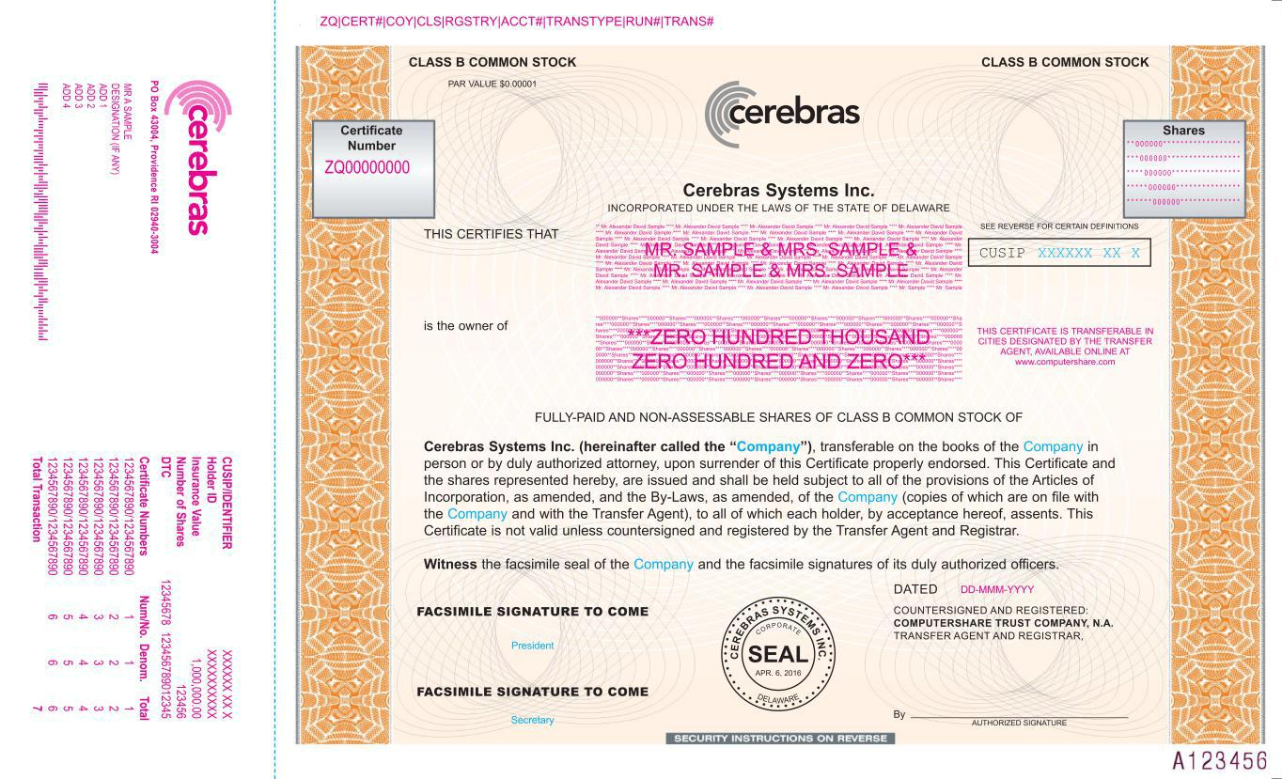

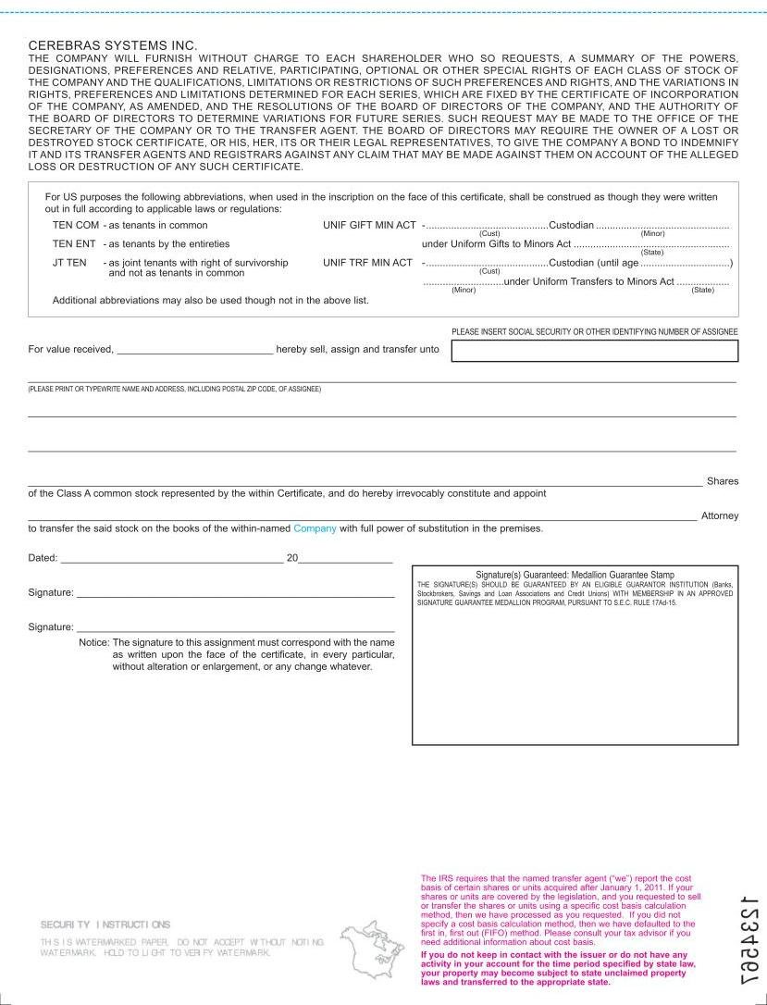

Exhibit 5.1

801 Jefferson Avenue, Suite 300

Redwood City, California 94063

Tel: +1.650.328.4600 Fax: +1.650.463.2600

www.lw.com

FIRM / AFFILIATE OFFICES

Austin Milan

Beijing Munich

Boston New York

Brussels Orange County

Chicago Paris

Dubai Riyadh

Düsseldorf San Diego

Frankfurt San Francisco

Hamburg Seoul

Hong Kong Silicon Valley

Houston Singapore

London Tel Aviv

Los Angeles Tokyo

Madrid Washington, D.C.

May 14, 2026

Cerebras Systems Inc.

1237 E. Arques Avenue

Sunnyvale, California 94085

Re: Registration Statement on Form S-8

To the addressee set forth above:

We have acted as counsel to Cerebras Systems Inc., a Delaware corporation (the “Company”), in connection with the preparation and filing by the Company on the date hereof with the Securities and Exchange Commission (the “Commission”) of a Registration Statement (the “Registration Statement”) on Form S-8 under the Securities Act of 1933, as amended (the “Act”), relating to the issuance of (i) up to 102,335,729 shares of Class A common stock, $0.00001 par value per share of the Company (the “Class A Shares”), and (ii) up to 53,882,184 shares of Class B common stock, $0.00001 par value per share of the Company (the “Class B Shares” and, together with the Class A Shares, the “Shares”), which may be issued pursuant to the Company’s 2016 Equity Incentive Plan (the “2016 Plan”), the Company’s 2026 Incentive Award Plan (the “2026 Plan”), and the Company’s 2026 Employee Stock Purchase Plan (the “ESPP” and, together with the 2016 Plan and the 2026 Plan, the “Plans”). This opinion is being furnished in connection with the requirements of Item 601(b)(5) of Regulation S-K under the Act, and no opinion is expressed herein as to any matter pertaining to the contents of the Registration Statement or related prospectus, other than as expressly stated herein with respect to the issue of the Shares.

As such counsel, we have examined such matters of fact and questions of law as we have considered appropriate for purposes of this letter. With your consent, we have relied upon certificates and other assurances of officers of the Company and others as to factual matters without having independently verified such factual matters. We are opining herein as to the General Corporation Law of the State of Delaware (the “DGCL”), and we express no opinion with respect to any other laws.

Subject to the foregoing and the other matters set forth herein, it is our opinion that as of the date hereof, when the Shares shall have been duly registered on the books of the transfer

May 14, 2026

Page 2

agent and registrar therefor in the name or on behalf of the purchasers, and have been issued by the Company for legal consideration of not less than par value in the circumstances contemplated by the applicable Plan, assuming in each case that the individual issuances, grants, or awards under the applicable Plan are duly authorized by all necessary corporate action and duly issued, granted, or awarded and exercised in accordance with the requirements of law and the applicable Plan (and the agreements duly adopted thereunder and in accordance therewith), the issue and sale of the Shares will have been duly authorized by all necessary corporate action of the Company, and the Shares will be validly issued, fully paid, and nonassessable. In rendering the foregoing opinion, we have assumed that the Company will comply with all applicable notice requirements regarding uncertificated shares provided in the DGCL.

This opinion is for your benefit in connection with the Registration Statement and may be relied upon by you and by persons entitled to rely upon it pursuant to the applicable provisions of the Act. We consent to your filing this opinion as an exhibit to the Registration Statement. In giving such consent, we do not thereby admit that we are in the category of persons whose consent is required under Section 7 of the Act or the rules and regulations of the Commission thereunder.

Sincerely,

/s/ Latham & Watkins LLP

Exhibit 23.2

Consent of Independent Registered Public Accounting Firm

We hereby consent to the incorporation by reference in this Registration Statement on Form S-8 of our report dated September 18, 2025, relating to the consolidated financial statements of Cerebras Systems Inc. (the Company), which is included in the Company’s Registration Statement on Form S-1 (No. 333-295145).

/s/ BDO USA, P.C.

San Jose, California

May 14, 2026

Exhibit 23.3


KPMG LLP

2755 Augustine Drive

Suite 701

Santa Clara, CA 95054

Consent of Independent Registered Public Accounting Firm

We consent to the use of our report dated March 31, 2026, with respect to the consolidated financial statements of Cerebras Systems Inc., incorporated herein by reference.

/s/ KPMG LLP

Santa Clara, California

May 14, 2026

KPMG LLP, a Delaware limited liability partnership, and its subsidiaries are part of the KPMG global organization of

independent member firms affiliated with KPMG International Limited, a private English company limited by guarantee.

